4th annual  FXF CUP  sponsorship opportunities |  |  | 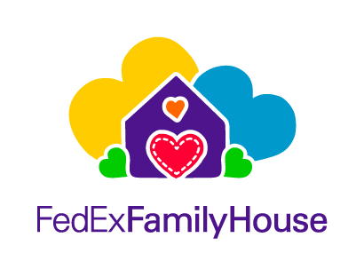
Contact info |  | Troy Landi  Par Tee Time Events LLC  Event Director/Owner |  |  |  | 816.405.1238  Troy@parteetimeevents.com  Parteetimeevents.com
Event type  Charity golf tournament. Participants will be provided with a round of golf and lunch. Awards will be given to the winners. There will be raffle prizes plus much more! |  | Event location  This year’s event will be held at the Reunion Resort in Kissimmee, FL. The tournament will be played on the Palmer course on September 1, 2024. |  |  |  | Cause  This event is dedicated to raising funds for the FedExFamilyHouse. This organization houses families that have members being treated at Le Bonheur Children’s Hospital in Memphis, TN.

Sponsorship tiers

Trophy Sponsor - $1000
Sponsored Team (Two players) / Upgraded Signage (hole 1 or 10) / Digital Display Ad / Logo on Trophy Display

Gold Level Sponsor - $500
Upgraded Signage (hole 1 or 10)

Tee Box Sponsor - $250
Signage on the tee box of one hole (holes 2-9 or 11-18)

Green (Flag) Sponsor - $250
Custom Pin Flag

All event Sponsors are encouraged to distribute company swag in our registration gift bags.

